**User Stories:**

View products: As a Customer,

I want to Easily view products on the website.

So that I can quickly assess available options and make informed decisions.

Purchase Products: As a: Customer

I want to: Make a purchase on the website.

So that: I can complete the transaction smoothly, with a straightforward and user-friendly checkout process.

Create Product Review: As a: Satisfied (or Dissatisfied) Customer

I want to: Share my experience with a purchased product.

So that: Other buyers can make informed decisions based on real user feedback.

Manage customer information: As an Administrator,

I want to efficiently manage user information.

So that I can maintain accurate and up-to-date records within the system.

**Marketing admin user stories:**

Manage products: As a Store Manager,

I want to efficiently manage products in the system

So that I can keep the product catalog up-to-date and provide accurate information to customers.

Report Product Sales: As a Product Manager,

I want to efficiently manage products in the sales system.

So that I can ensure accurate inventory, pricing, and availability for effective sales operations.

Warehouse clerk:

Fulfil order: As a Warehouse Operator,

I want to efficiently fulfill customer orders

So that I can ensure accurate and timely delivery of products.

Warehouse Manager:

As a Inventory Manager,

I want to generate comprehensive reports on current inventory levels .

So that I can make informed decisions regarding restocking and inventory management.

**Sprint Backlog:**

The Sprint Backlog is a plan by and for the Developers.

The sprint backlog is a list of tasks identified by the Scrum team to be completed during the [Scrum](https://www.mountaingoatsoftware.com/agile/scrum) sprint.

During the sprint planning meeting, the team selects some number of product backlog items, usually in the form of [user stories](https://www.mountaingoatsoftware.com/agile/user-stories), and identifies the tasks necessary to complete each user story.

It's critical that the team selects the items and size of the sprint backlog.

The sprint backlog is commonly maintained as a spreadsheet.

Sprint

In [Agile product development](https://www.techtarget.com/searchsoftwarequality/definition/agile-software-development), a sprint is a set period of time during which specific work has to be completed and made ready for review.

Each sprint begins with a planning meeting.

The duration of a sprint is determined by the [scrum master](https://www.techtarget.com/whatis/definition/scrum-master).

During the sprint, the team holds daily stand-up meetings to discuss progress.

Product Owner

A product owner is a role on a Scrum team that is responsible for the project's outcome.

PO do:

Connects with Customer.

Contributes to the vision and roadmap.

Supports the Team in Delivering.

Product Backlog:

The Product Backlog is an emergent, ordered list of what is needed to improve the product.

A product backlog is a list of the new features, changes to existing features, bug fixes, infrastructure changes, or other activities that a team may deliver in order to achieve a specific outcome.

Scrum Master:

A Scrum master is a professional who leads a team through a project using Agile project management techniques.

A Scrum Master facilitates all the communication and collaboration between leadership and team players to ensure a successful outcome.

A Scrum Master focuses on the team, taking steps to ensure the team and individual team members achieve success.

Daily scrum:

The daily scrum is a 15-minute [Scrum meeting](https://www.mountaingoatsoftware.com/agile/scrum/meetings) held on on each day of a sprint. ( daily standup or daily stand up meeting).

The purpose of the daily scrum is for the team to inspect and adapt its progress.

Daily scrums are strictly time-boxed to 15 minutes.

Sprint Retrospective:

The Sprint Retrospective occurs after the [**Sprint Review**](https://www.visual-paradigm.com/scrum/what-is-sprint-review/) and prior to the next [**Sprint Planning**](https://www.visual-paradigm.com/scrum/what-is-sprint-planning/).

 A sprint retrospective meeting is to find what activities and “things” the team is doing well, what activities should be continued, and what “more” can be done to improve the next Sprint to be more enjoyable or productive.

**SCRUM Framework and related terms:**

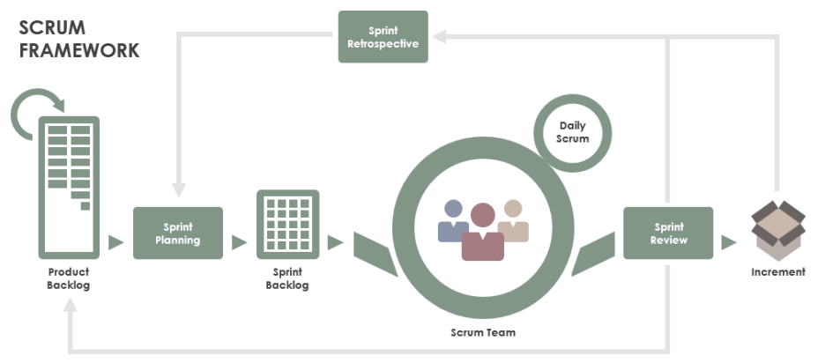The Product Owner is responsible for managing the Product Backlog, prioritizing the items, and ensuring that the team understands the requirements.

Example: John is the Product Owner for a mobile application development project. He collaborates with stakeholders to gather requirements, prioritize features, and maintain a well-groomed Product Backlog.

**Product Backlog:** This is an ordered list of all the features, enhancements, and fixes that are needed for the product. The Product Backlog is managed and prioritized by the Product Owner.

Example: The Product Backlog for the mobile application includes features such as user authentication, in-app purchases, and push notifications, prioritized based on customer feedback and business value. 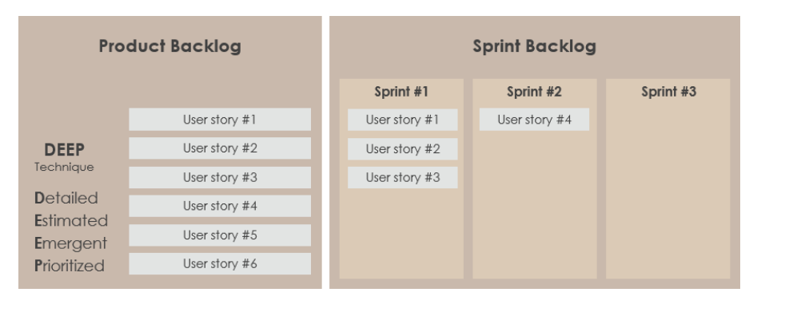

Sprint: A time-boxed iteration in which a potentially shippable product Increment is created. It typically lasts for two to four weeks.

Example: The team begins Sprint 1 with a goal to implement the user authentication feature from the Product Backlog within a two-week timeframe.

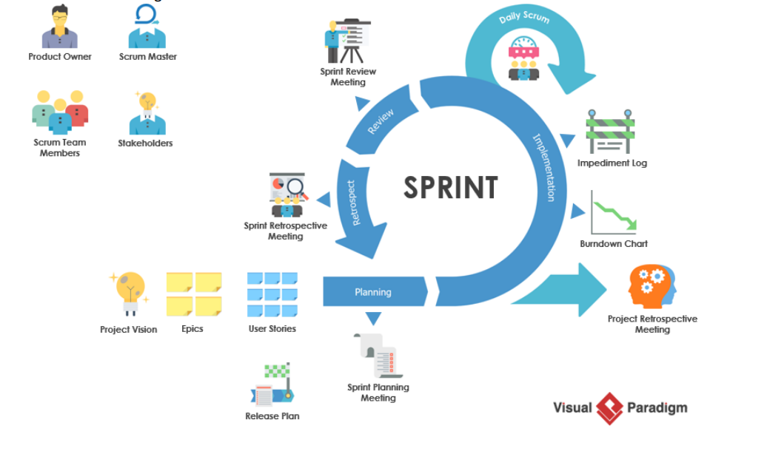Sprint Backlog: This is a subset of the Product Backlog items selected for the Sprint, along with a plan for delivering the product Increment and realizing the Sprint Goal.

Example: The Sprint Backlog for Sprint 1 includes specific tasks related to implementing the user authentication feature, such as designing the login screen, implementing backend APIs, and writing unit tests.

Scrum Master: The Scrum Master is responsible for ensuring that the Scrum framework is understood and followed by the team. They facilitate Scrum events, remove impediments, and coach the team.

Example: Emily is the Scrum Master for the development team. She facilitates the Daily Scrum, helps the team identify and resolve impediments, and ensures that the Sprint progresses smoothly.

Daily Scrum: Also known as the Daily Stand-up, this is a short daily meeting where team members synchronize their activities, discuss progress, and plan for the day.

Example: During Sprint 1, the team holds a Daily Scrum every morning to discuss what they did yesterday, what they plan to do today, and any obstacles they are facing in implementing the user authentication feature. Increment: At the end of each Sprint, the team delivers a potentially shippable product Increment, which is a concrete step toward the product's vision.

Example: By the end of Sprint 1, the team has successfully implemented the user authentication feature, and it is ready for testing and validation by stakeholders.

Sprint Retrospective: This is a meeting held at the end of each Sprint where the team reflects on their process, identifies what went well and what could be improved, and creates a plan for implementing those improvements in the next Sprint.

Example: After completing Sprint 1, the team holds a Sprint Retrospective to discuss what went well (e.g., effective collaboration) and what could be improved (e.g., clearer acceptance criteria). They decide to refine their estimation process for Sprint 2 to improve accuracy